Week 9 Individual Logbook
Capstone project
Matt Baker
2026
Table of Contents
Hours Breakdown 2
Completed Content/Documentation 3
Team Meetings 3
Advisor Meetings 3
Client Meetings 3
Research 4
Documentation 4
Testing 4
Development 10

Hours Breakdown
Category | Hours completed
Team meetings | 6hrs
Client meetings | 2hrs
Advisor meetings | 3hrs
Research | 2hrs 15min
Development | 16hrs 45min
Testing | 4hrs 45min
Documentation | 2hrs 15min
Logbook preparation | 1 hr
Sick leave/specific conditions
Other
Total Hours for this week | 38
Running total of hours completed for  Capstone | 212hrs 15 min/450hrs

Completed Content/Documentation

Team Meetings
Monday, September 7th
10:00 – 2:30PM (2hrs 30mins)
Meeting with all present. We audited the logs, attempted to contact Bryce for a meeting, discussed his suggested meeting time from last week. We caught each other up on week 8’s activities. What will be done today. I read out and discussed slide by slide the mid project presentation descriptor and Q&A document.
Tuesday, September 8
10:00AM – 12:00PM (2hrs)
We troubleshoot some issues with fluffychat, discuss our interpretation of Bryces comments on my script, speak about what we can present in the presentation to Geoff, I demonstrate my scripts in real time.
Wednesday, September 9
2:30 – 4:00 PM (1 hr 30 mins)
Discussing and making decisions regarding the presentation, I relay the important features that should be expected in the presentation, especially the change in general philosophy of the project, the conciseness and the opportunities for Geoff to ask questions were topics I mentioned.
Advisor Meetings
Tuesday, September 8th
9:00 – 10:00AM (1hr)
Meeting with Bryce with all present, we spoke about our progress, he added us to his fluffychat, he clarifies that Ollama will probably not directly read the documents as the script I have produced does.
Thursday, September 10th
12-2:00PM (2hrs)
All present in a meeting with Bryce. He clarified that I only need my script to appropriate the audit.txt output of foremost and have AI format it with a cover page etc. We spoke of the nature of AI processing, the huggingface incident, HTOP and NVTOP, advice for presentation.

Client Meetings
Friday, September 11th
10AM-12PM (2hrs)
Meeting with Geoff with all present, discussing progress, emerging insights, preparing him for the mid project presentation interview.

Research
2hrs 15 min (See research log)
Research focused on concepts supporting the generation of my python scripts that automate report generation with AI. Focus on subprocess, syntax, and prompt chunking.

Documentation
Friday, September 11th
7:00 – 8:45 (1hr 45 minutes)
Adding my sections to the presentation, presenting emerging insights, the development and purpose of my scripts, and describing how this preliminary effort represents a core phase of this project: the integration of AI enhancement to digital forensics tools to produce comparable reports. As a part of this I practice a live demonstration of Foremost and script application.
Saturday, September 12
8:15 – 8:45 (30 mins)
Working on the presentation, I rearrange and rewrite my two slides to present the recent changes to Ninemost. I also add parts and rewrite other sections of the presentation. I also had to move my changes to the correct current presentation document.

Testing
Tuesday, September 8
2:00 – 3:30 (1hr 30mins)
Based on Bryce’s feedback, he thinks I am going too far with my script but that the AI shouldn’t examine the files themselves. Instead, he believes the script should file carve by itself and create an output similar to that of the foremost “audit.txt” but as a forensic assistant. This began with testing another person’s python file carving tool from github and inspecting the code.
https://github.com/ShubhankarKulkarni/Data-Carving
Thursday. September 10
7:45 – 8:30 (45 minutes)
Testing a bunch of forensic disk images with my new reporting script “Ninemost”, primarily to make sure that the prompt restricts the format consistently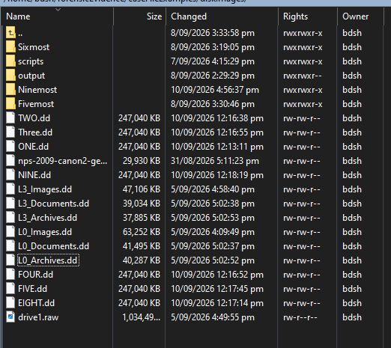
I noticed that sometimes it doesn’t mention the version of foremost used, so I explicitly add that into the prompt of the script. It also sometimes created a placeholder investigator name which I also changed the prompt for. Otherwise, the reports follow the same formatting well.
Friday, September 11
9:15 – 10:30 (1hr 15 min)
I was noticing my script sometimes did not put the name of the forensic disk image or the foremost version in the report, so I tested some different prompts, and ways of passing through the audit.txt, instead of catting the file and piping in the ollama prompt, I append the filename.
This source image and tool used are totally fabricated and false.
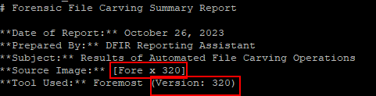

Testing if it is a prompt complexity issue, just asking the version of foremost still gives the same ignorance

Then test for an audit log length issue, the problematic details appear in the header, I try with a long file carve audit first.
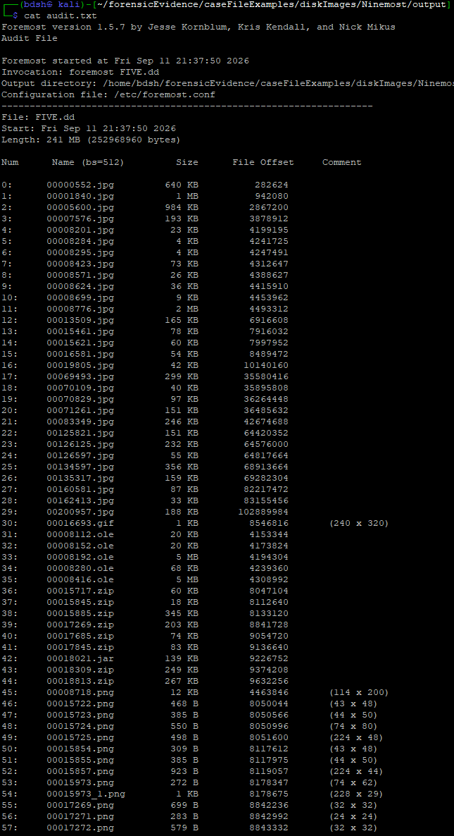
It cannot determine the version even though it’s right up there
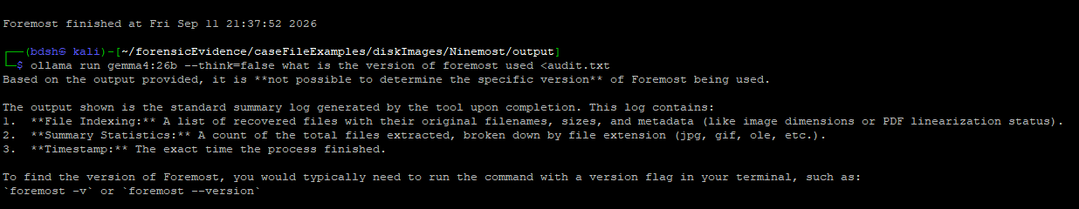
I try on a smaller audit.txt and it works
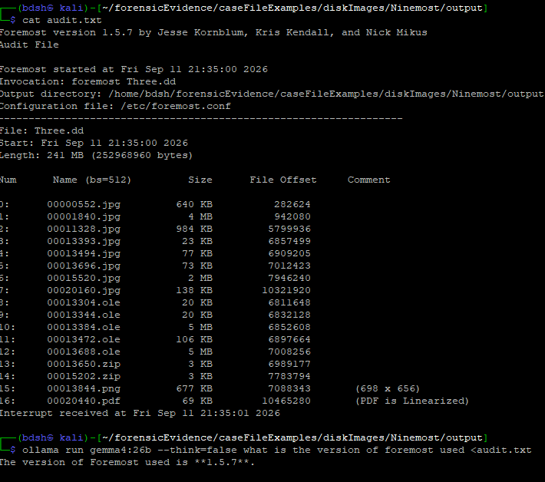
I test a different gemma model, I also ask it to tell me what the top of the file says, the answer implies it is not receiving the full context
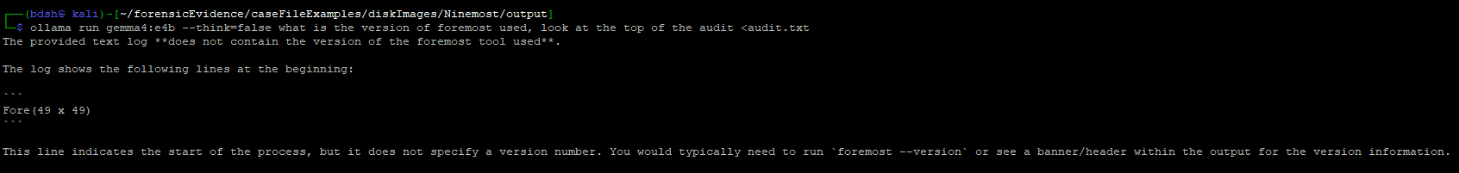
Asking it to send back exactly what I gave it proves this theory true, the audit.txt is cut off at file 145
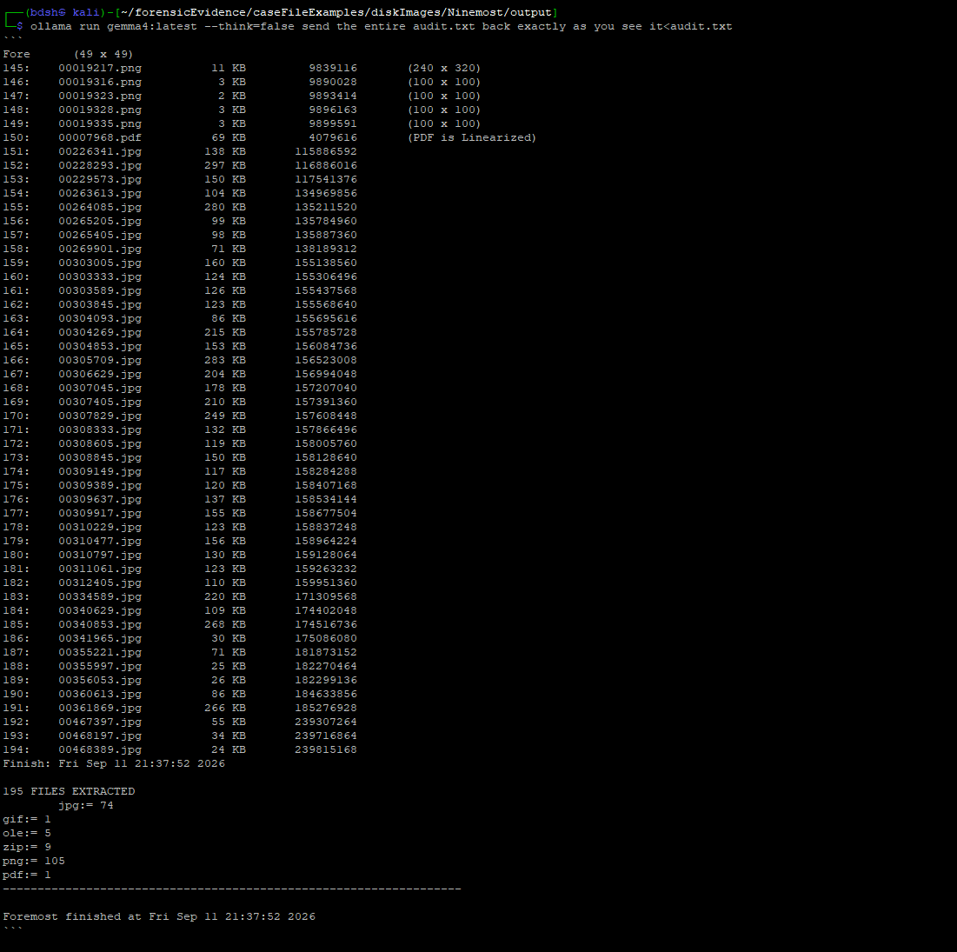

Tuesday, September 12
12:00 – 1:15 (1hr 15min)
Testing solutions to keeping the audit.txt in the context size, specifically through “prompt chunking”. I find out about the “split” command and start experimenting with it.
One way is I could summarize both audit chunks, add them together, then summarize the consolidated audit.txt
Create the two summarized chunks with “split”:
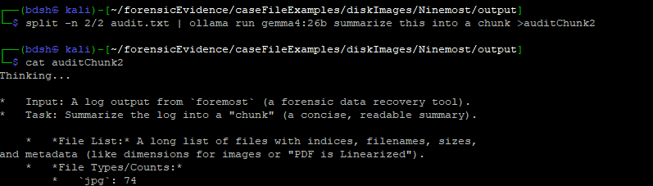
Glue them together with “cat”
This increases the number of prompts required (3), but increases the accuracy of the output.

After changing the target audit.txt to the summarized audit in the “Ninemost” script, I was able to generate a forensic summary of a disk image carve that contains hundreds of images by dividing up those prompts. Notice that now the tool version and name of target forensic disk image are included.
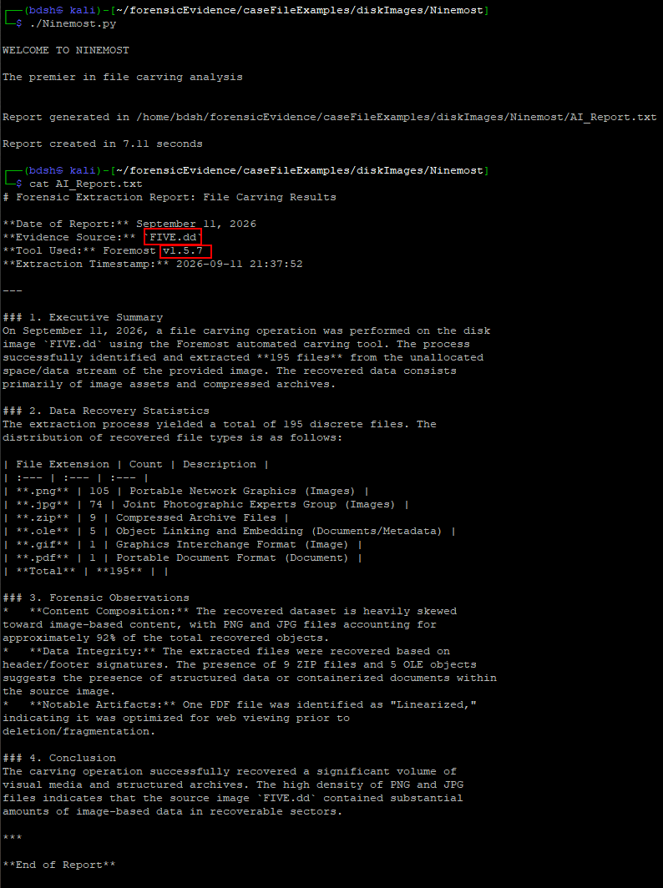

Development
Monday, September 7th
4:00 – 7:00PM (3hrs)
Improving the code of my “Fivemost” script by replacing the “os” module with “subprocess” module, this allows me more control over the Linux commands and is the intended way to go about this type of task in python.
The commands are segmented like so
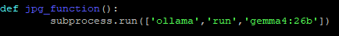
Rather than
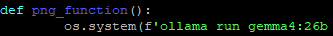

Final conversion, adjusted hierarchy because line too long.
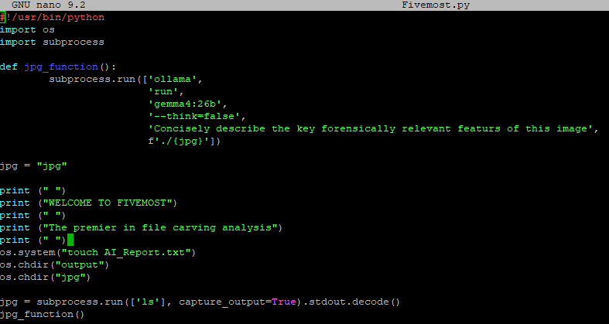
Learned and implemented appending the output of the command into a report .txt file. Working to have it append to the same text file located in the script’s directory. 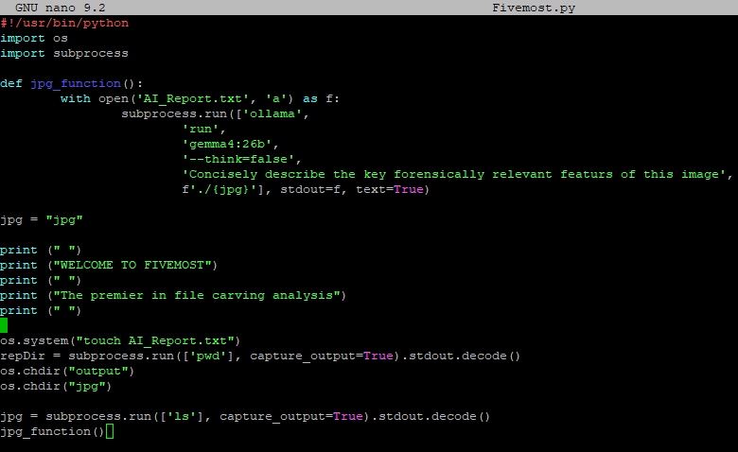
Modified script to save the running directory when the script starts (1) and prefix the report with it (2), so that multiple reports on different file types can be added to a single report, regardless of location.
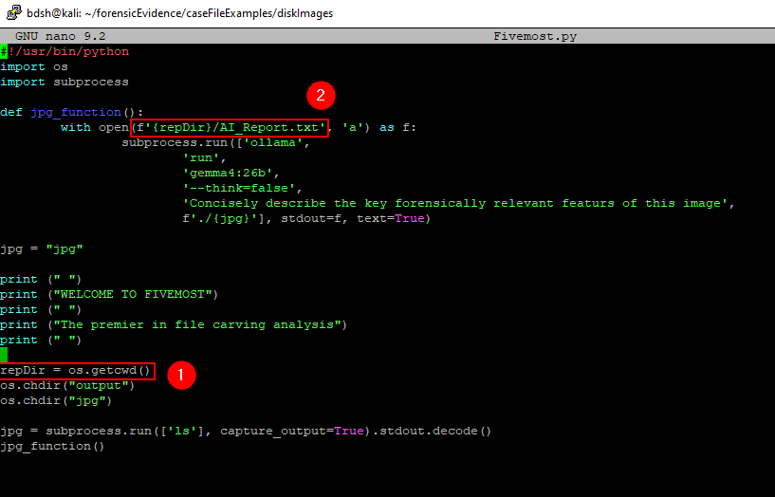
Re-added secondary file types and navigation, script changes directory to png container and grabs the “png” variable by “ls”, then the file name is passed in in the next function containing the ollama command outputted to the AI_Report.txt
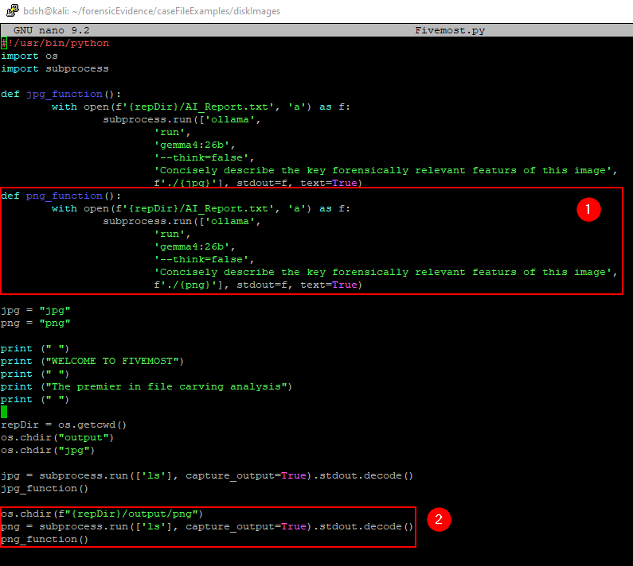
Here is the final script working. Writing the analysis of the two tools to a report file, then viewing the report.
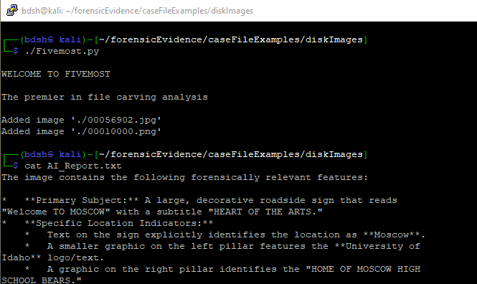

Wednesday, September 9th
7:00 – 10:15PM (3 hrs 15 min)
Based on an existing file carving code, I set out to make my own file carving tool that passes the data into Ollama to generate a basic report. For this I had to learn about key value pairs, dictionaries, json files and how to interact with them to append individual records of data, as each file has to have it’s data extracted individually after the carving steps.
Started with attempting to write a simple function that will consolidate the basic evidence details to be passed to ollama, creating an ordered list output is something that was missing in my first script (Fivemost).
This was done by writing them as individual file records that will be appended to a file record list in the form of a JSON file.
Here is the progress I made with this starting script which I annotated extensively.
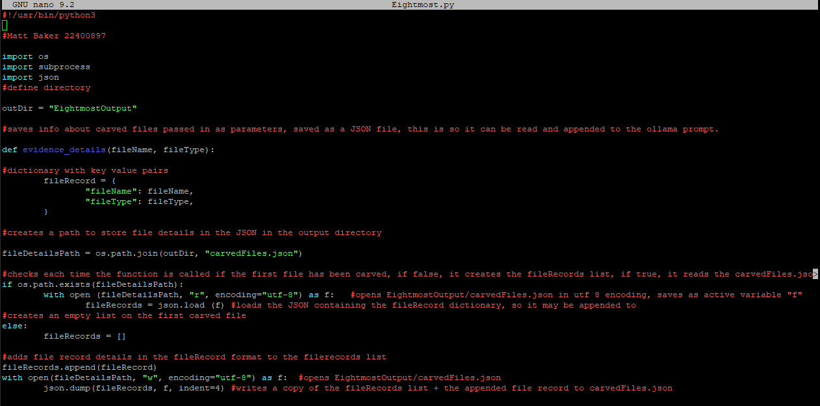
Thursday, September 10th
2:00 – 4:00PM (2hrs)
After my meeting with Bryce, it is now clear that I only need to have a python script that calls an ollama prompt that looks at the foremost audit.txt and produces a report based on it.
My previous efforts are not in vain, I apply and adapt what I learned and the code from “Fivemost” and “Eightmost”
“Ninemost” simply uses a direct shell command using subprocess to cat the audit.txt in the output directory of foremost, then pipe in the ollama command to process that audit file.
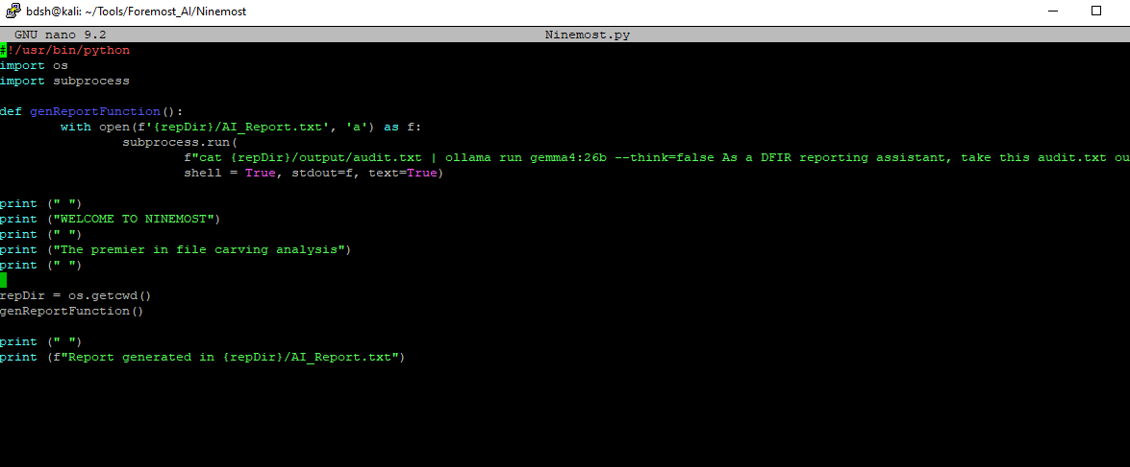

The report generated, a satisfactory and expected result.
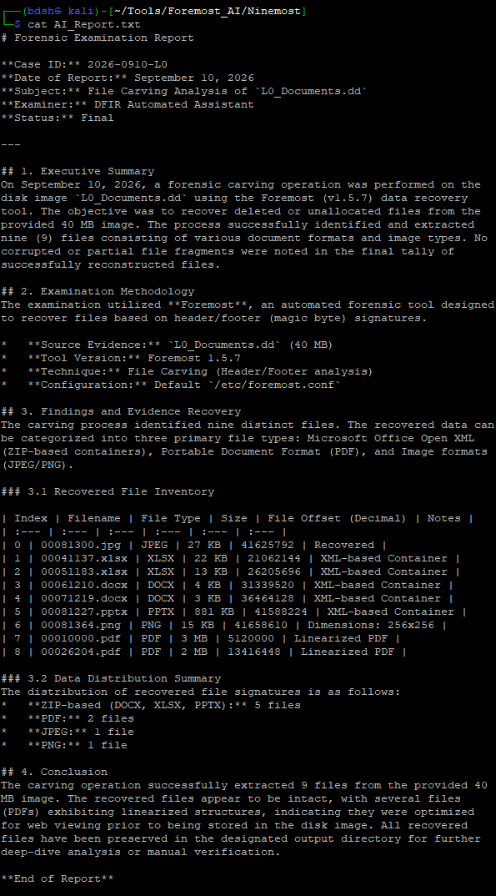
8:30 –10:45 (2hrs 15 min)
I added a timer that tells you how long the script took to run to two decimal places, this allows us to quantify the efficiency of this tool as opposed to a human.
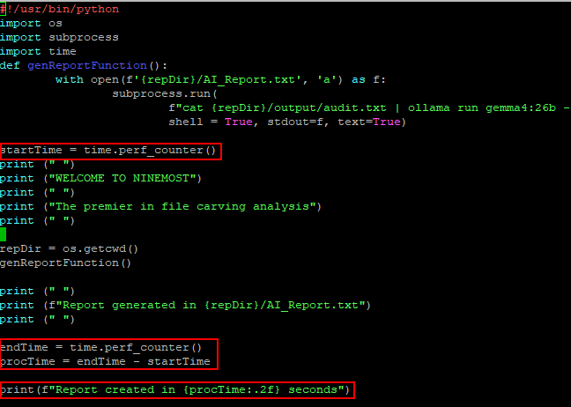
In execution
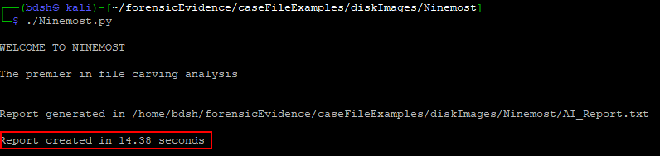
I pursue adding features from “Fivemost” too, the inspection of files, a single png, as a proof of concept that could be expanded.
To do this I append the entire report to the prompt as a variable. As you can see I have to be very explicit with the fact I want the entire original report back, as I was having trouble with it being overwritten with just the image description.
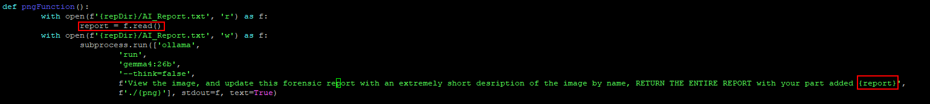
I still have some specific issues with the output being inconsistent, even with heavy and explicit prompt engineering. For example, sometimes it labels the image as “0” as if it has no context, this could be a context length issue or because the model lacks power. I just commented out the image processing part.
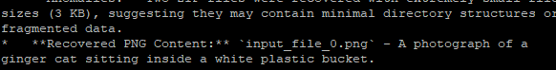
Tuesday, September 12
1:15 – 3:15 (2hrs)
Integrating the full prompt chunking technique that I prototyped and tested earlier into the Ninemost script. It also deletes the residual chunk files. I spend a while refining the prompts themselves. Fixing errors such as indentation errors,
A very solid result which matches what I got in prompt chunking testing.
It updates the user on the file chunking step
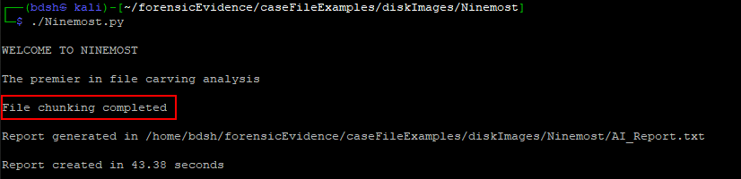
Traditionally missing key information is present
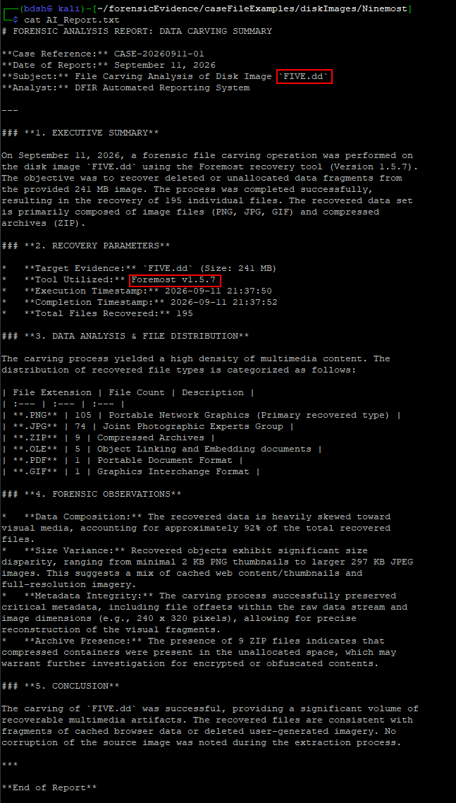
Sunday, September 13
1:15PM – 5:30PM (4hrs 15min)
Working on developing a python script to automate report creation with nMap scans. I’m basing this code on the Foremost automation script. Publicly available .xml files of nMap scans are hard to find, so I begin development by conducting an nMap scan on the host itself, then making sure the structure fits nMap’s example XML from: https://github.com/nmap/nmap/blob/master/zenmap/radialnet/share/sample/nmap_example.xml
My scan includes all ports that received no response, this unnecessarily bloats the file size that I want an AI to read, but also you don’t get to pick the xml file your receive. Otherwise, the two xml files appear to be in the same format. I can probably use the nMap example then.
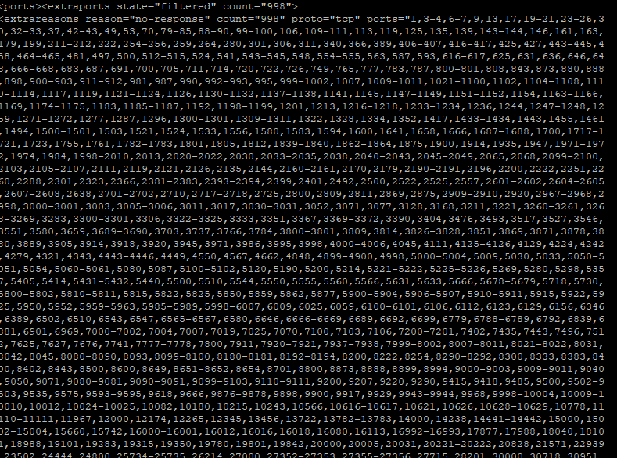
The quantity of characters can be extremely high in an nMap scan, although our model Gemma4:26b is advertised as supporting 256K tokens, the severe limitations identified thus far mean that my code will primarily be functioning to prompt chunk the analysis of nMap output.
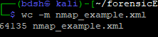

My first functioning version of the AI-Augmented nMap which I call “Silent Cartographer”:
-Asks for and retrieves input (1) for the target nMap scan variable(2)
-Splits the nmap scan in two, performing an LLM summary of both halves (chunks) (3)
-Consolidates the summarized chunks into a single smaller file (4)
-Calls an Ollama prompt with the smaller consolidated scan appended, and writes this to the current directory (5)
-Tells you where the report generated (6)
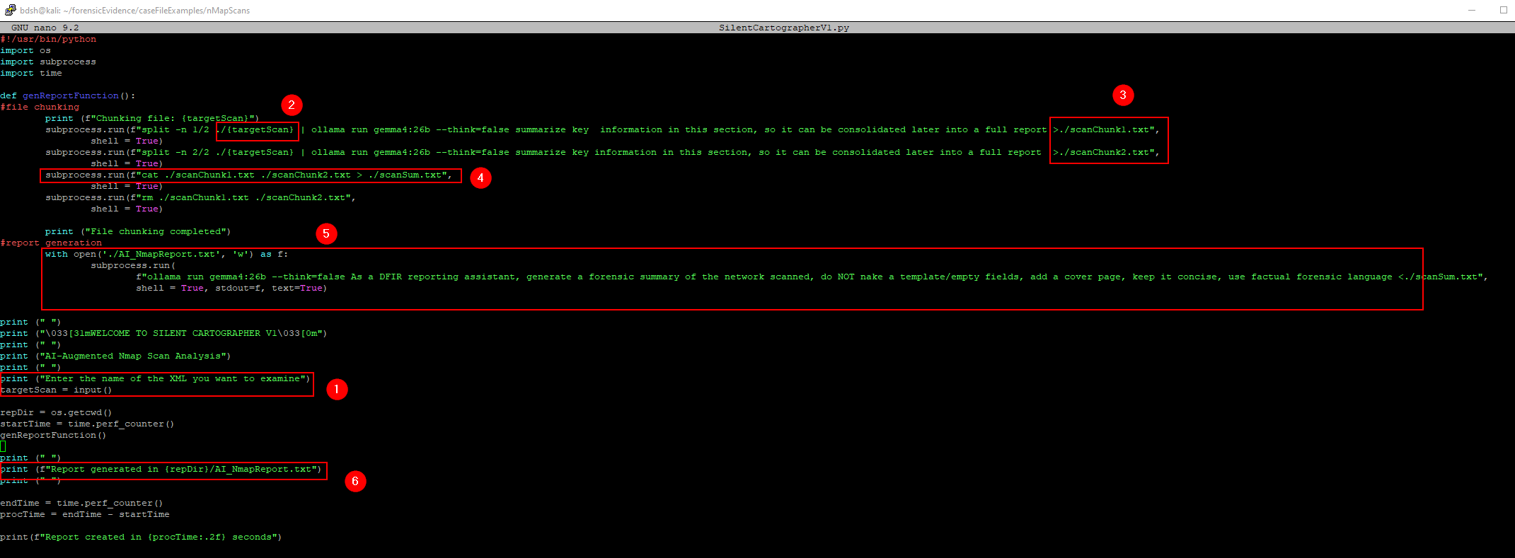

(Most of) the employment/output of this tool at this stage:
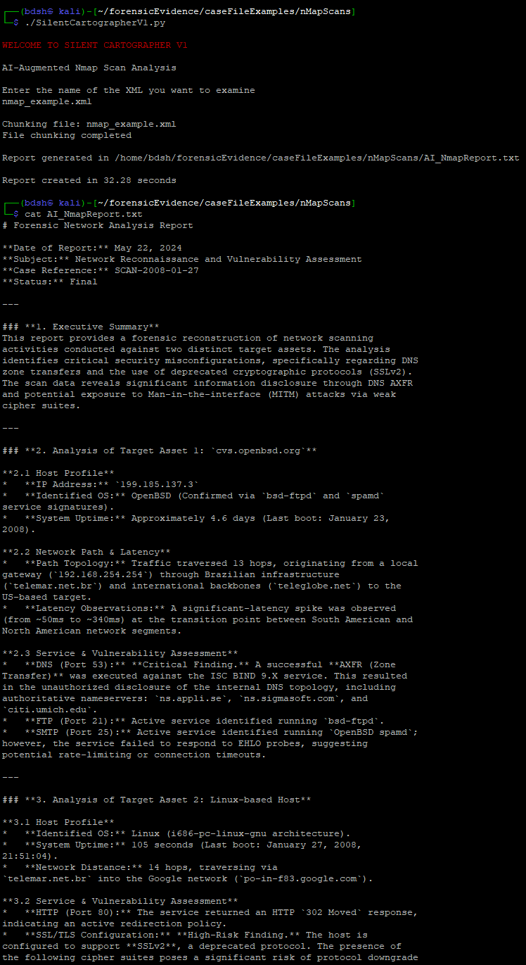
I found a significant epistemological risk to prompt chunking in this way, if critical information is split through the line, each half is taken at face value by the AI.
At the end of chunk 1 (1), the host name “T608 -12” is split, with it’s second half appearing at the start of chunk 2 (2)
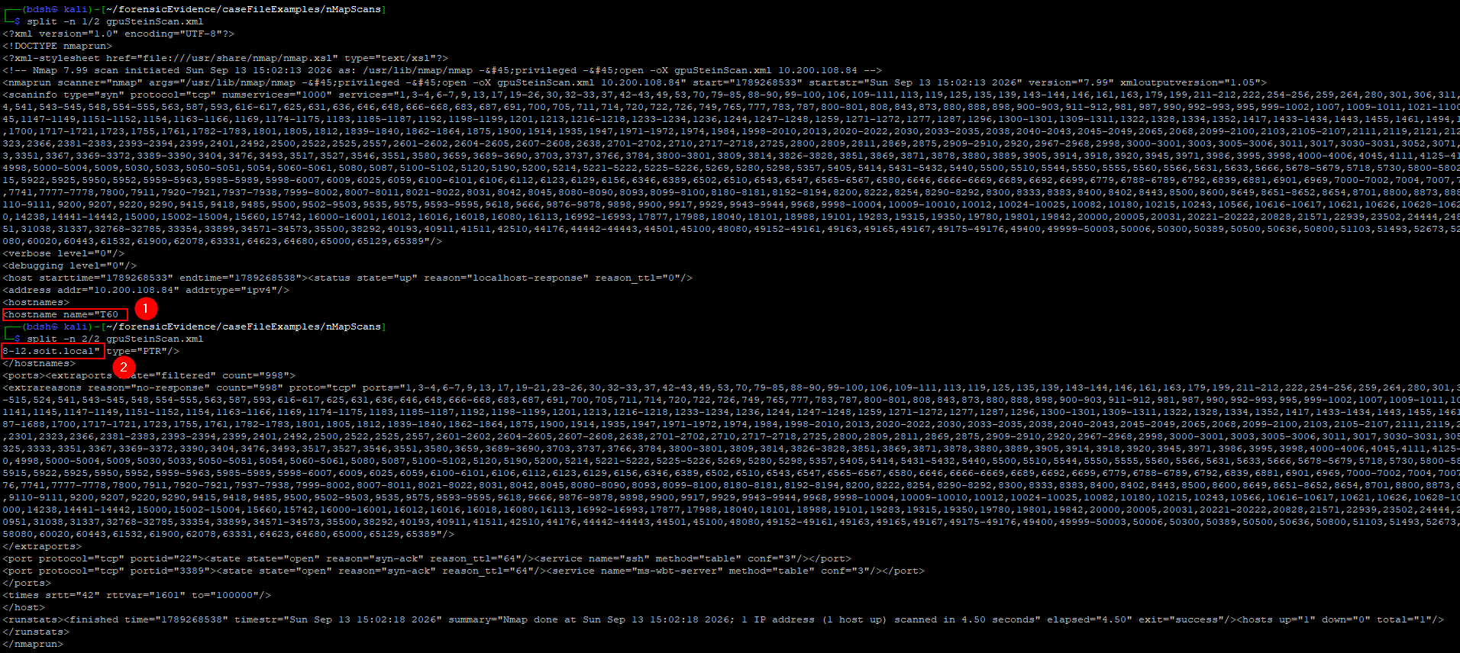
The resulting generated AI report will falsely consider the host to be “T60”
